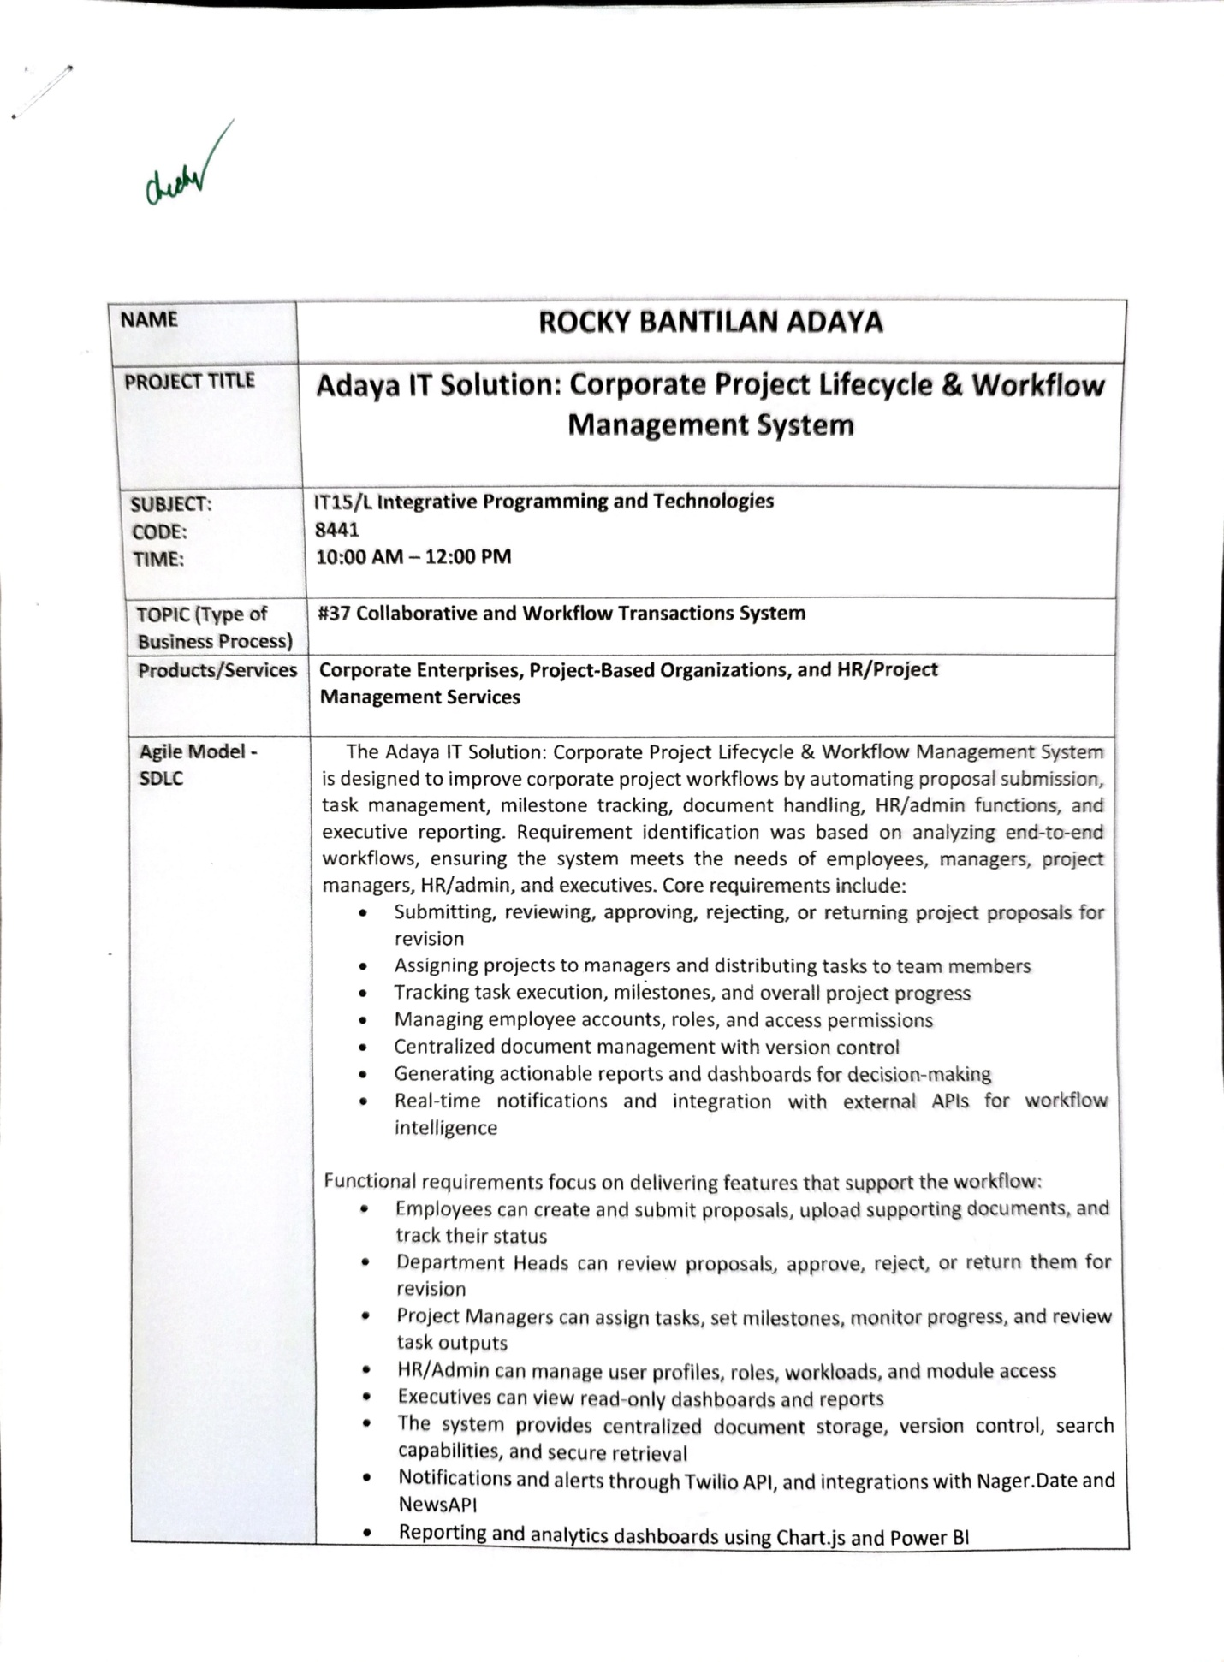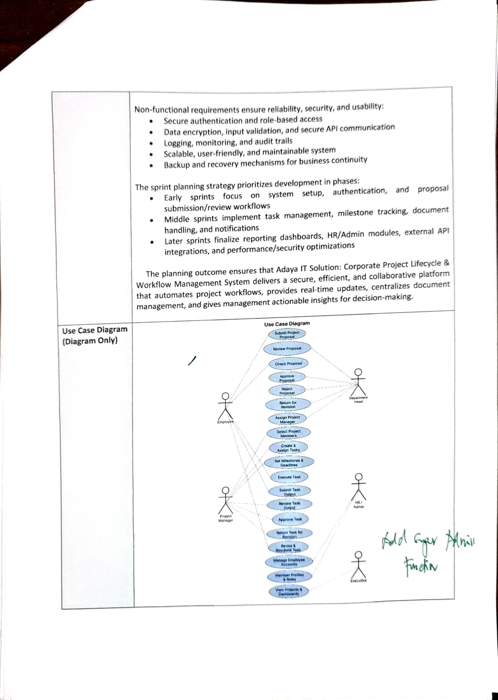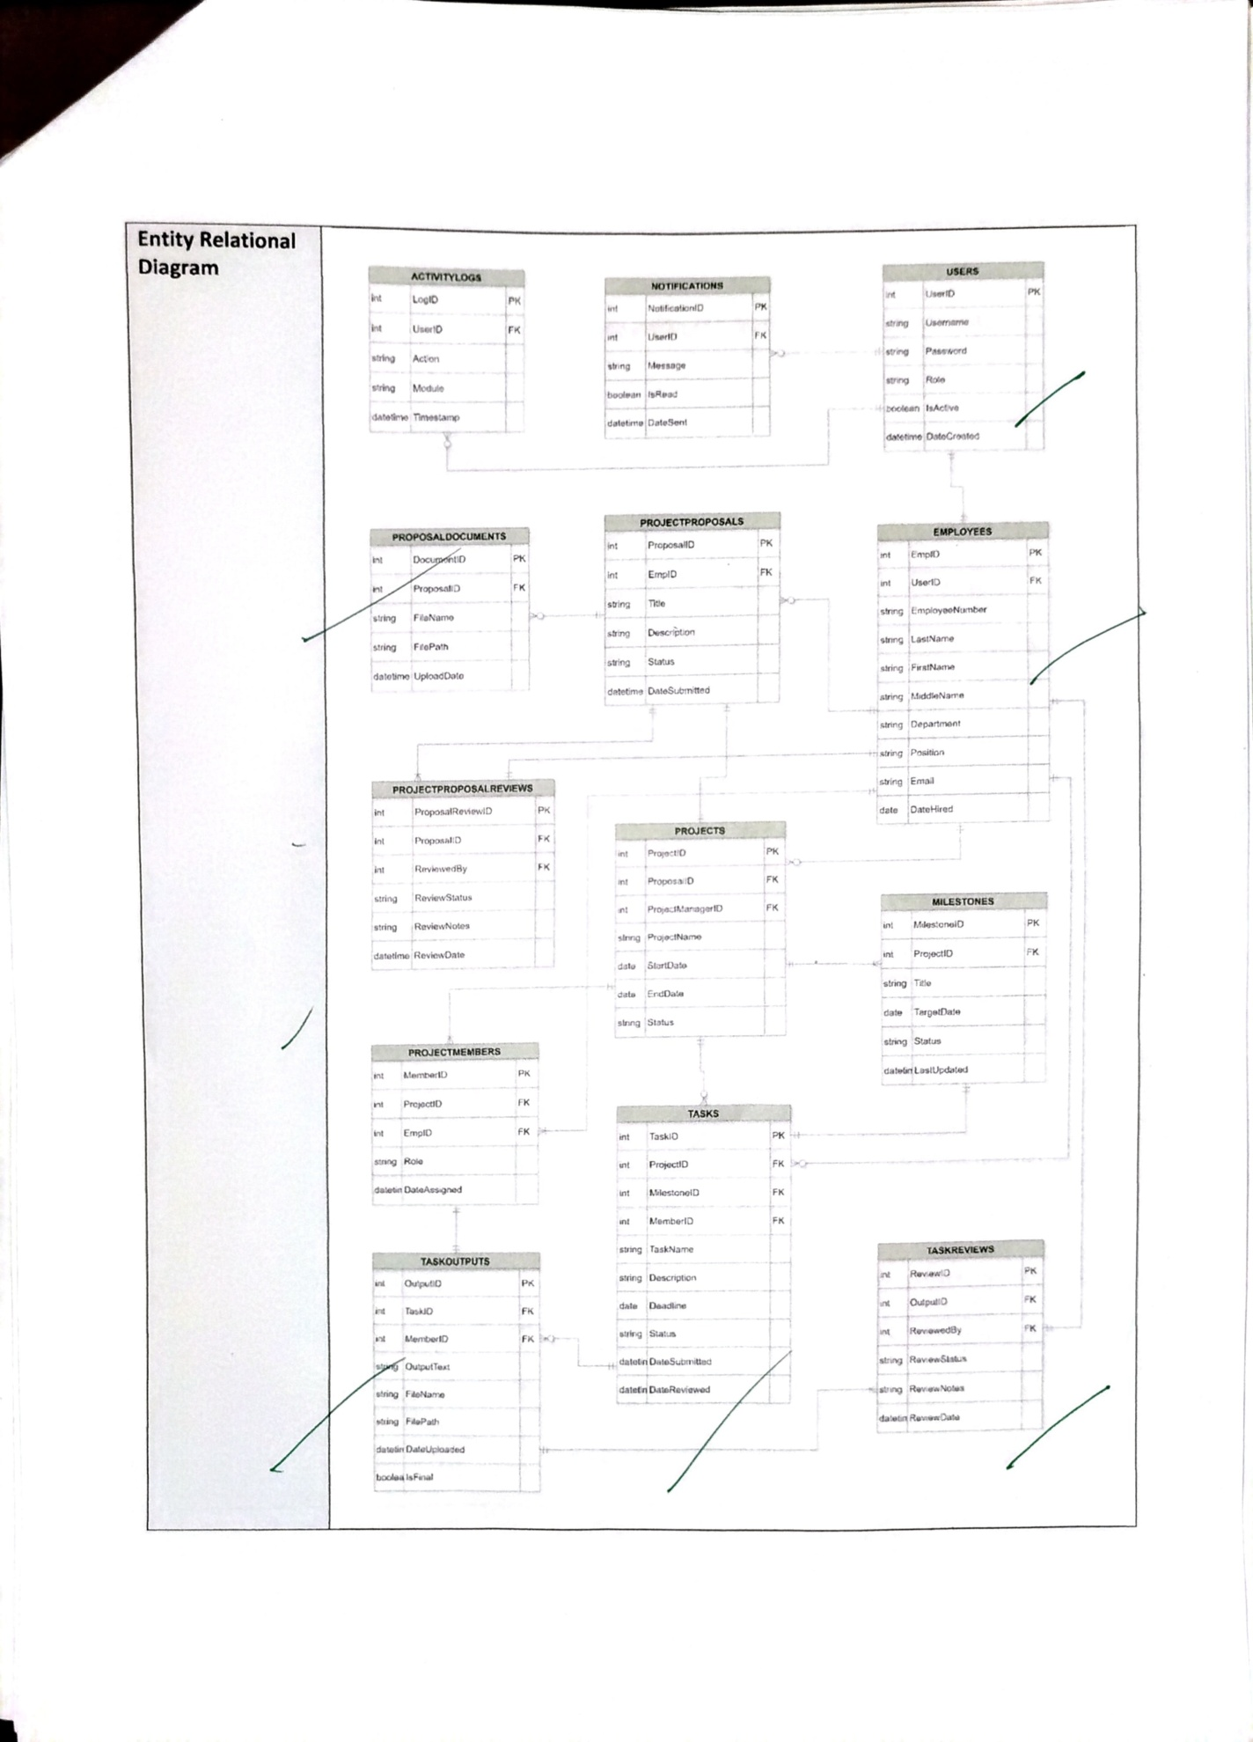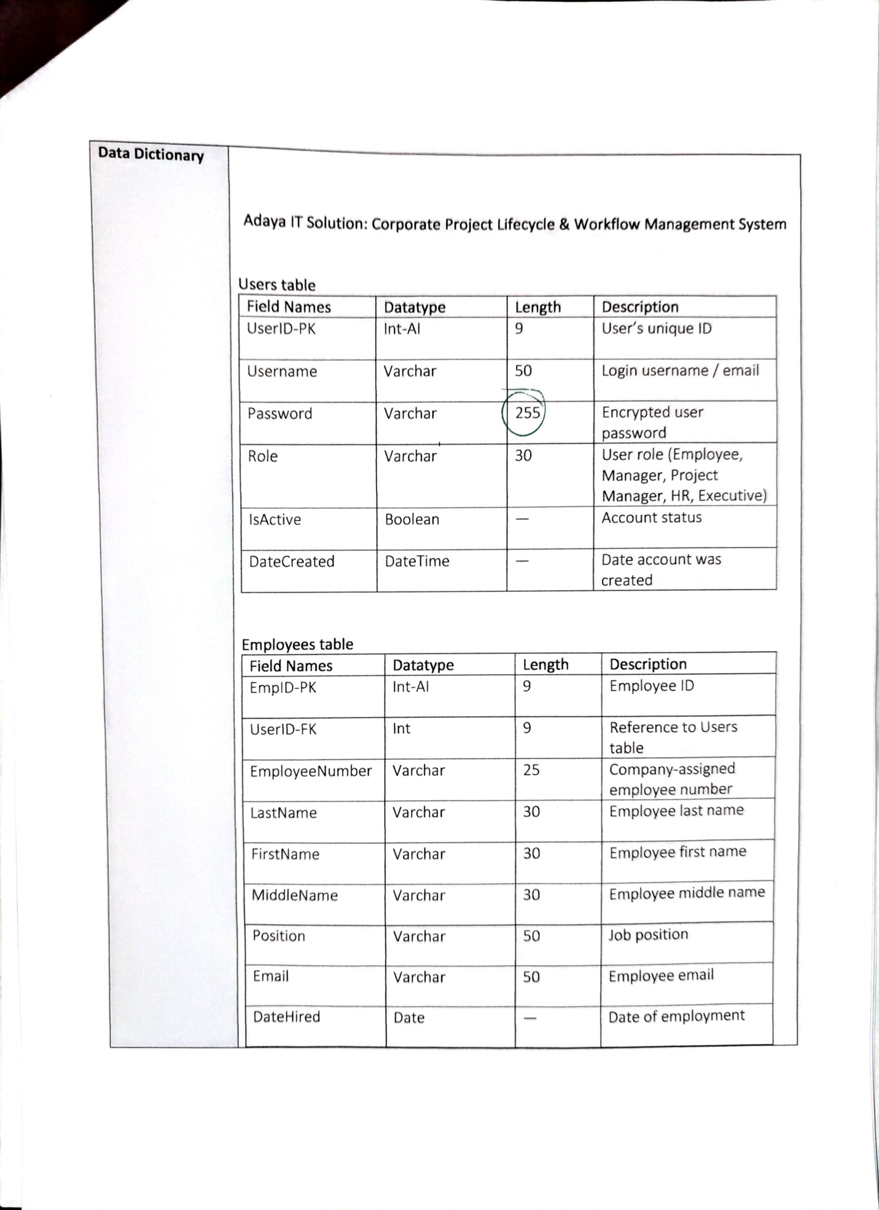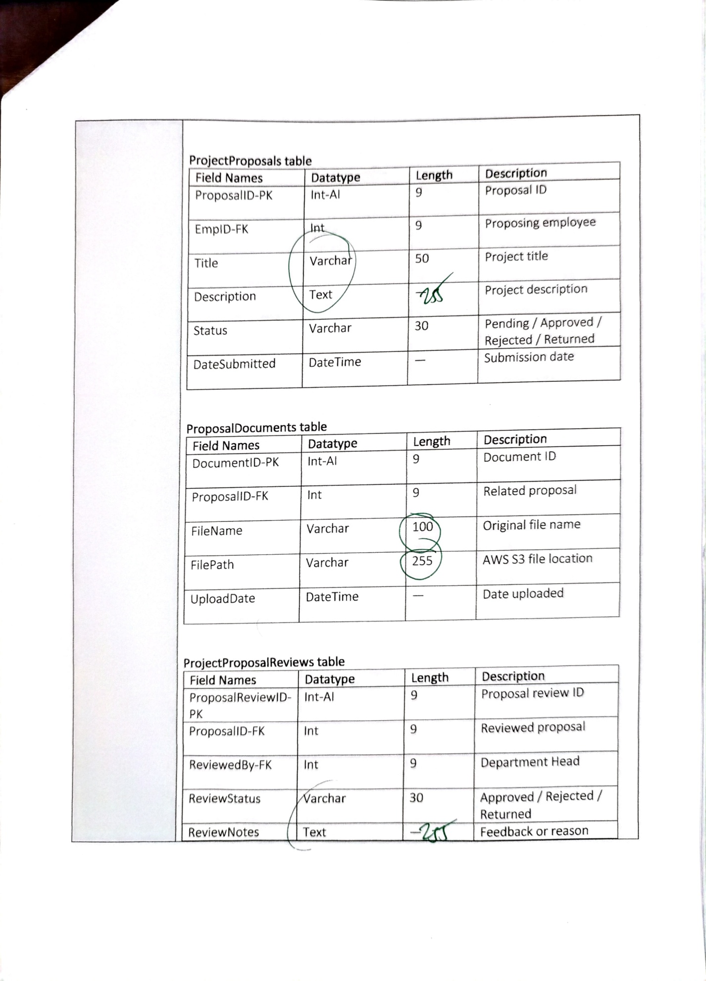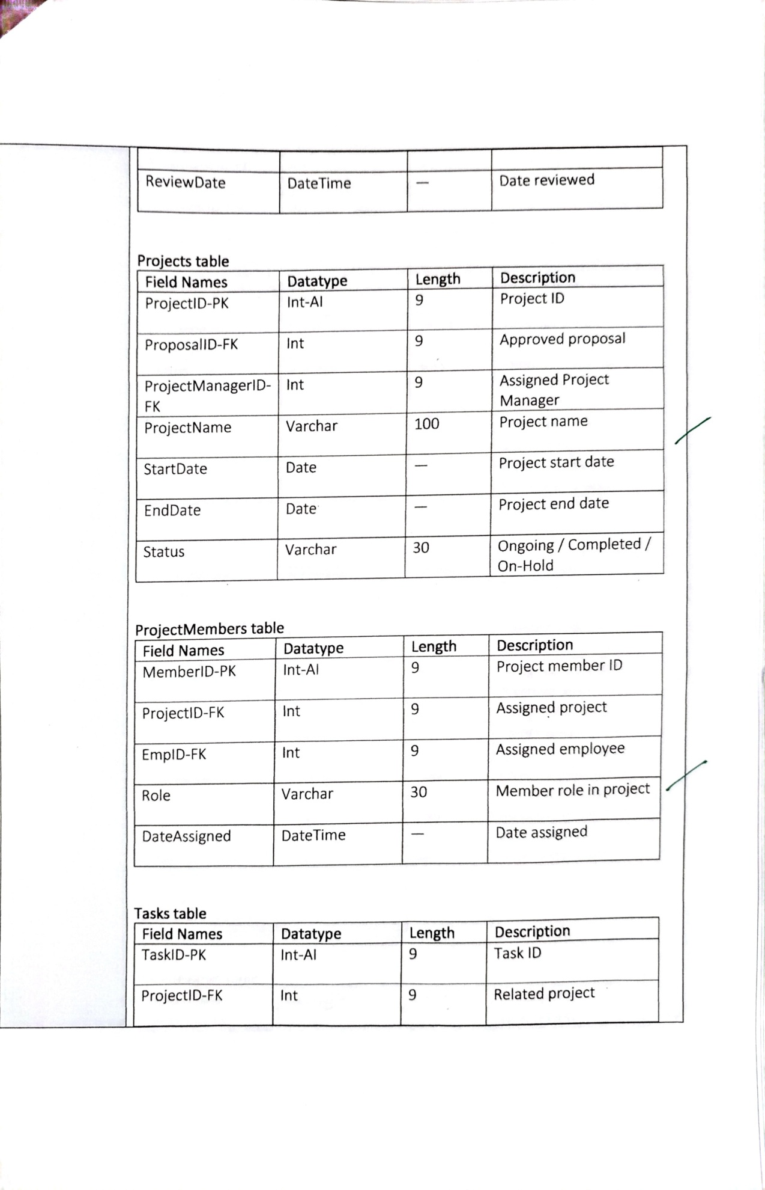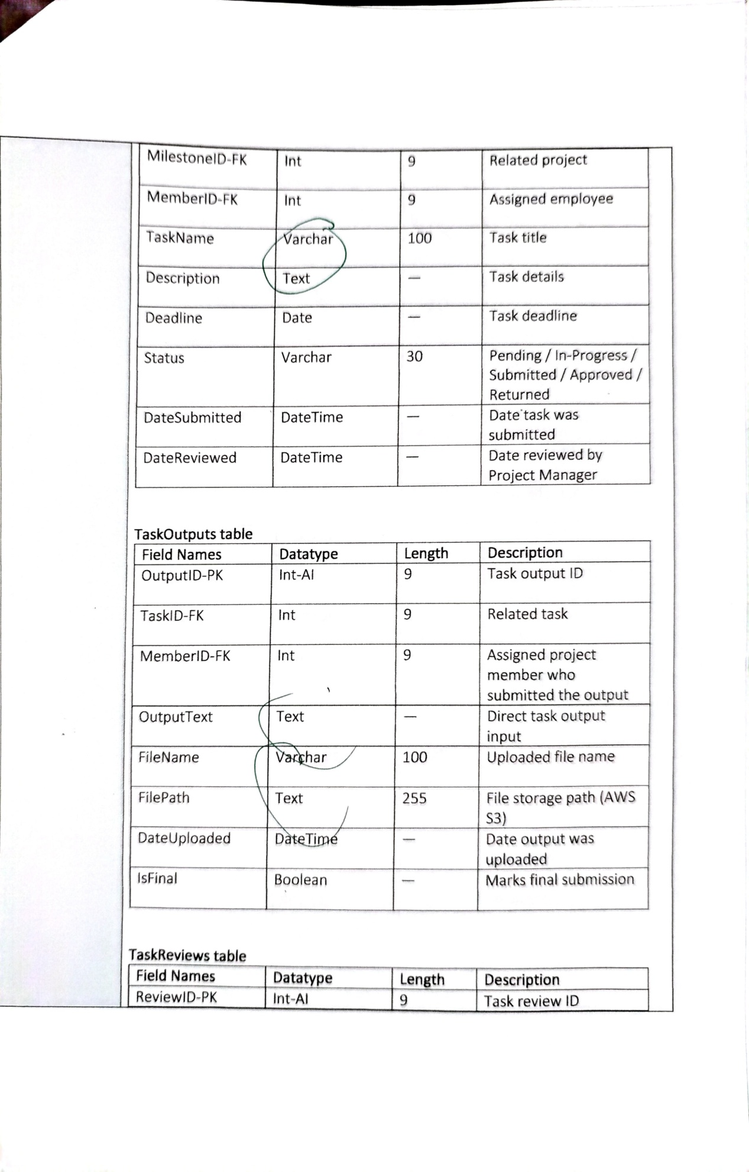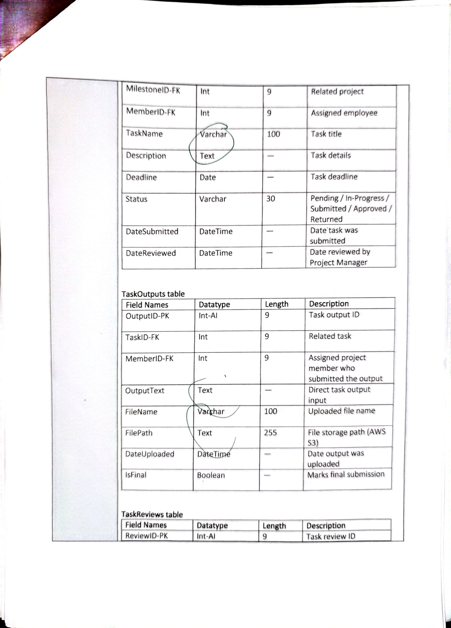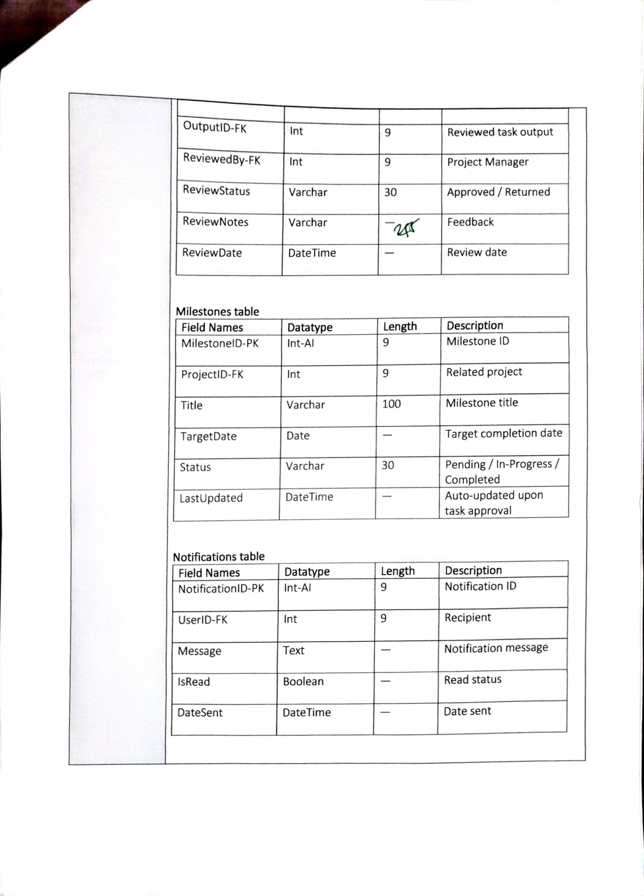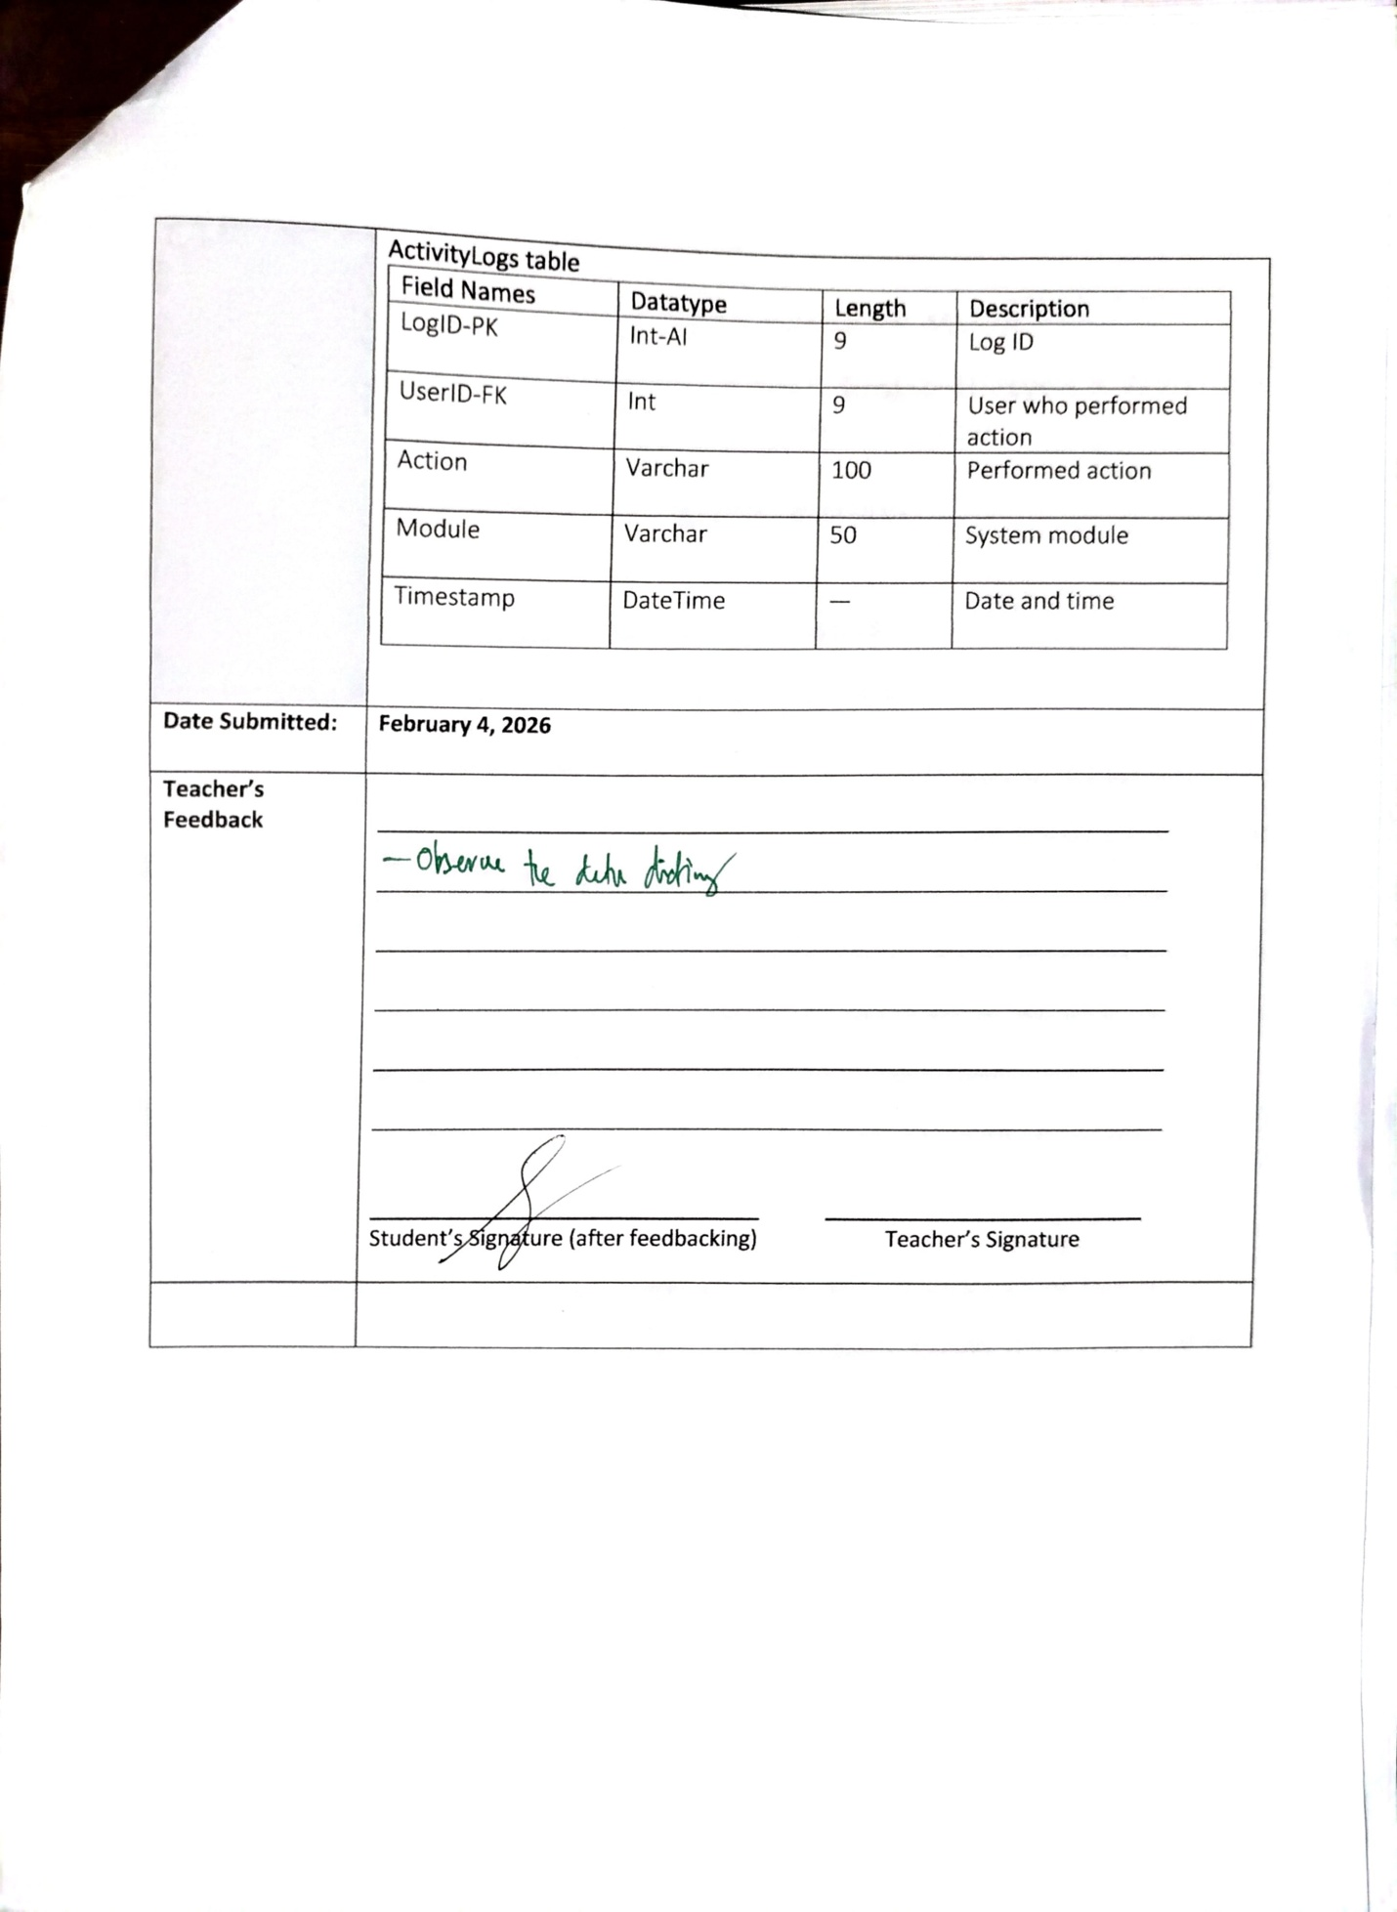

NAME | ROCKY BANTILAN ADAYA
PROJECT TITLE | Adaya IT Solution: Corporate Project Lifecycle & Workflow Management System
SUBJECT:  CODE:  TIME: | IT15/L Integrative Programming and Technologies  8441  10:00 AM – 12:00 PM
TOPIC (Type of Business Process) | #37 Collaborative and Workflow Transactions System
Products/Services | Corporate Enterprises, Project-Based Organizations, and HR/Project  Management Services
Agile Model - SDLC | The Adaya IT Solution: Corporate Project Lifecycle & Workflow Management System is designed to improve corporate project workflows by automating proposal submission, task management, milestone tracking, document handling, HR/admin functions, and executive reporting. Requirement identification was based on analyzing end-to-end workflows, ensuring the system meets the needs of employees, managers, project managers, HR/admin, and executives. Core requirements include:  - Submitting, reviewing, approving, rejecting, or returning project proposals for revision  - Assigning projects to managers and distributing tasks to team members  - Tracking task execution, milestones, and overall project progress  - Managing employee accounts, roles, and access permissions  - Centralized document management with version control  - Generating actionable reports and dashboards for decision-making  - Real-time notifications and integration with external APIs for workflow intelligence  Functional requirements focus on delivering features that support the workflow:  - Employees can create and submit proposals, upload supporting documents, and track their status  - Department Heads can review proposals, approve, reject, or return them for revision  - Project Managers can assign tasks, set milestones, monitor progress, and review task outputs  - HR/Admin can manage user profiles, roles, workloads, and module access  - Executives can view read-only dashboards and reports  - The system provides centralized document storage, version control, search capabilities, and secure retrieval  - Notifications and alerts through Twilio API, and integrations with Nager.Date and NewsAPI  - Reporting and analytics dashboards using Chart.js and Power BI  Non-functional requirements ensure reliability, security, and usability:  - Secure authentication and role-based access  - Data encryption, input validation, and secure API communication  - Logging, monitoring, and audit trails  - Scalable, user-friendly, and maintainable system  - Backup and recovery mechanisms for business continuity  The sprint planning strategy prioritizes development in phases:  - Early sprints focus on system setup, authentication, and proposal submission/review workflows  - Middle sprints implement task management, milestone tracking, document handling, and notifications  - Later sprints finalize reporting dashboards, HR/Admin modules, external API integrations, and performance/security optimizations  The planning outcome ensures that Adaya IT Solution: Corporate Project Lifecycle & Workflow Management System delivers a secure, efficient, and collaborative platform that automates project workflows, provides real-time updates, centralizes document management, and gives management actionable insights for decision-making.
Use Case Diagram  (Diagram Only) | 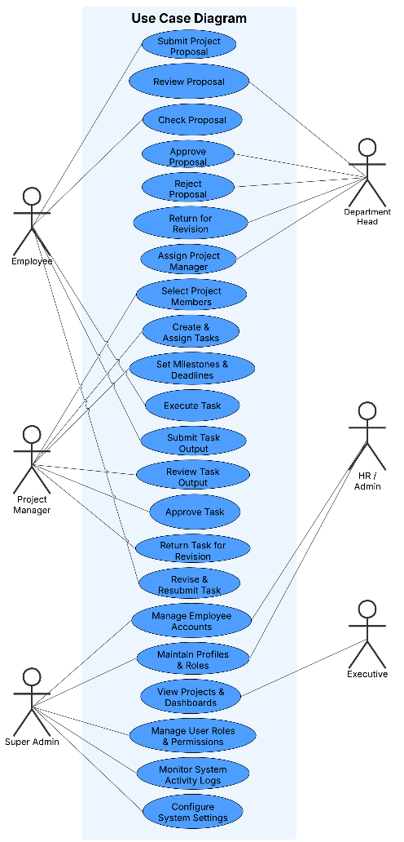
Entity Relational Diagram | 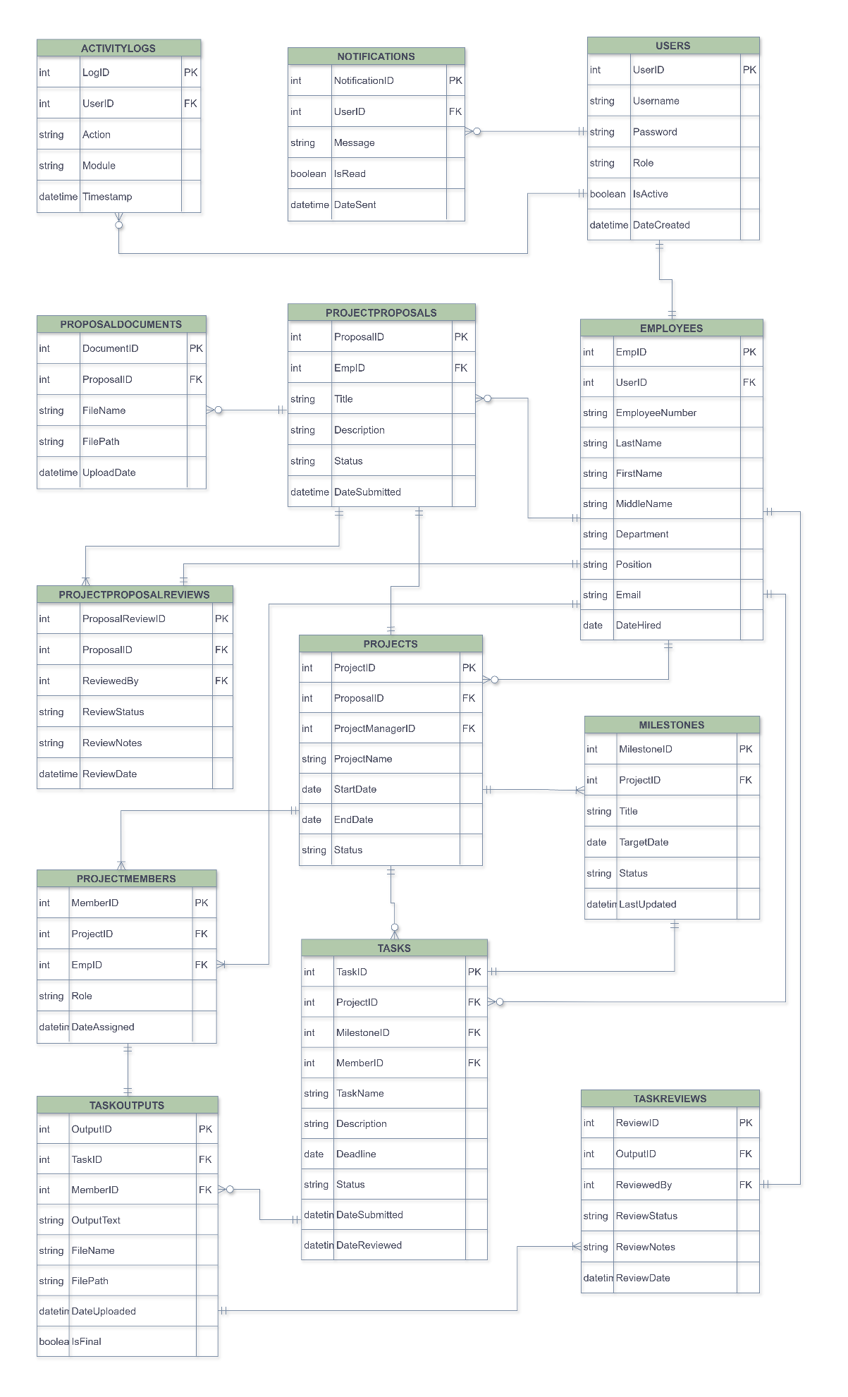
Data Dictionary | Adaya IT Solution: Corporate Project Lifecycle & Workflow Management System  Users table  Field Names Datatype Length Description  UserID-PK Int-AI 9 User’s unique ID  Username Varchar 50 Login username / email  Password Varchar 128 Encrypted user password  Role Varchar 30 User role (Employee, Manager, Project Manager, HR, Executive)  IsActive Boolean — Account status  DateCreated DateTime — Date account was created  Employees table  Field Names Datatype Length Description  EmpID-PK Int-AI 9 Employee ID  UserID-FK Int 9 Reference to Users table  EmployeeNumber Varchar 25 Company-assigned employee number  LastName Varchar 30 Employee last name  FirstName Varchar 30 Employee first name  MiddleName Varchar 30 Employee middle name  Position Varchar 50 Job position  Email Varchar 50 Employee email  DateHired Date — Date of employment  ProjectProposals table  Field Names Datatype Length Description  ProposalID-PK Int-AI 9 Proposal ID  EmpID-FK Int 9 Proposing employee  Title Varchar 50 Project title  Description Varchar 255 Project description  Status Varchar 30 Pending / Approved / Rejected / Returned  DateSubmitted DateTime — Submission date  ProposalDocuments table  Field Names Datatype Length Description  DocumentID-PK Int-AI 9 Document ID  ProposalID-FK Int 9 Related proposal  FileName Varchar 50 Original file name  FilePath Varchar 150 AWS S3 file location  UploadDate DateTime — Date uploaded  ProjectProposalReviews table  Field Names Datatype Length Description  ProposalReviewID-PK Int-AI 9 Proposal review ID  ProposalID-FK Int 9 Reviewed proposal  ReviewedBy-FK Int 9 Department Head  ReviewStatus Varchar 30 Approved / Rejected / Returned  ReviewNotes Varchar 255 Feedback or reason  ReviewDate DateTime — Date reviewed  Projects table  Field Names Datatype Length Description  ProjectID-PK Int-AI 9 Project ID  ProposalID-FK Int 9 Approved proposal  ProjectManagerID-FK Int 9 Assigned Project Manager  ProjectName Varchar 100 Project name  StartDate Date — Project start date  EndDate Date — Project end date  Status Varchar 30 Ongoing / Completed / On-Hold  ProjectMembers table  Field Names Datatype Length Description  MemberID-PK Int-AI 9 Project member ID  ProjectID-FK Int 9 Assigned project  EmpID-FK Int 9 Assigned employee  Role Varchar 30 Member role in project  DateAssigned DateTime — Date assigned  Tasks table  Field Names Datatype Length Description  TaskID-PK Int-AI 9 Task ID  ProjectID-FK Int 9 Related project  MilestoneID-FK Int 9 Related project  MemberID-FK Int 9 Assigned employee  TaskName Varchar 100 Task title  Description Varchar 255 Task details  Deadline Date — Task deadline  Status Varchar 30 Pending / In-Progress / Submitted / Approved / Returned  DateSubmitted DateTime — Date task was submitted  DateReviewed DateTime — Date reviewed by Project Manager  TaskOutputs table  Field Names Datatype Length Description  OutputID-PK Int-AI 9 Task output ID  TaskID-FK Int 9 Related task  MemberID-FK Int 9 Assigned project member who submitted the output  OutputText Varchar 255 Direct task output input  FileName Varchar 50 Uploaded file name  FilePath Varchar 150 File storage path (AWS S3)  DateUploaded DateTime — Date output was uploaded  IsFinal Boolean — Marks final submission  TaskReviews table  Field Names Datatype Length Description  ReviewID-PK Int-AI 9 Task review ID  OutputID-FK Int 9 Reviewed task output  ReviewedBy-FK Int 9 Project Manager  ReviewStatus Varchar 30 Approved / Returned  ReviewNotes Varchar 255 Feedback  ReviewDate DateTime — Review date  Milestones table  Field Names Datatype Length Description  MilestoneID-PK Int-AI 9 Milestone ID  ProjectID-FK Int 9 Related project  Title Varchar 100 Milestone title  TargetDate Date — Target completion date  Status Varchar 30 Pending / In-Progress / Completed  LastUpdated DateTime — Auto-updated upon task approval  Notifications table  Field Names Datatype Length Description  NotificationID-PK Int-AI 9 Notification ID  UserID-FK Int 9 Recipient  Message Text — Notification message  IsRead Boolean — Read status  DateSent DateTime — Date sent  ActivityLogs table  Field Names Datatype Length Description  LogID-PK Int-AI 9 Log ID  UserID-FK Int 9 User who performed action  Action Varchar 100 Performed action  Module Varchar 50 System module  Timestamp DateTime — Date and time
Date Submitted: | February 16, 2026
Teacher’s Feedback | _________________________________________________________________  _________________________________________________________________  _________________________________________________________________  _________________________________________________________________  _________________________________________________________________  _________________________________________________________________  ________________________________ __________________________  Student’s Signature (after feedbacking) Teacher’s Signature

